Projecting a sustainable metallic/fabric dome
An EPS@ISEP 2016 Spring Project

Abstract—A dome is a structure which has a lot of advantages concerning the energy costs, use of materials, assemblage and structural strength. The aim for this study is to design a geodesic dome with a diameter of 6,8 meter which can be used as a green house or winter garden. The dome should be easily assembled and should also consist of an automatic door and an automatic window. In order to accomplish this task, a research has been executed. This research was in particularly focused on the type of components that have already been used in previous cases.
The design that was chosen for the dome has a lot of advantages regarding the strength of the structure itself. A simple design for the nodes will be used, because it has the best properties in general. The design of the automatic door and -window is based on easy, but efficient ideas. The automatic door and -window will also be able open if the climate inside the dome will be dissatisfactory. This will be accomplished by humidity- and temperature sensors inside the dome.
A scale prototype is made for this design. Functional tests were executed on this prototype. As a result, every component of the dome is functional.
Keywords—Engineering Education, Collaborative Learning, European Project Semester, Dome, Sustainable, Easy to Assemble.

Introduction
The Fabric and Metallic Dome project is one of the two dome projects that are executed at the Instituto Superior de Engenharia do Porto during a European Project Semester in the spring semester of 2016.
A European Project Semester, abbreviated as EPS, is a project where engineering studying students have to accomplish a project in a team in which every team member of this group has another scientific background and another background. The project that needs to be executed is about a multidisciplinary problem which overlaps every study of each team member. Diversity and collaborative learning are two main concepts that are the essence of this program.
This paper presents one of the five EPS projects that are executed in the spring semester of 2016. The main objectives of this project, is to design a dome composed of a metallic support structure and a fabric cover. The dome must be a V3 or V4 geodesic dome with a diameter of 6.8 meters. The dome must also be equipped with and automatic window and door, which can be opened by the use of sensors.
This paper presents the product development of the fabric & metallic dome. But it also shows marketing plan, eco-eficiency measures for sustainability, ethical and deontological concerns, which is also a part of the EPS program.

State of the art

General concepts of building a dome
A dome is an architectural element which consists of a hemisphere or the upper half of an ellipsoid. Currently, a dome is increasingly used as a complete structure. There are different possibilities to construct a dome. The most common used technique is to acquire the structure with icosahedrons. An icosahedron is a polyhedron with twenty faces. [1] This makes the implementation very easy, because all the elements have the same shape. Another possibility for constructing the spherical structure is to use squares and rectangles. The problem here is that all rectangle or square have another shape. This makes it more expensive and difficult to build.
The application for the dome is very decisive for the choice of the materials that are to be used. If the dome must be movable, low-weight materials should be used. Dependable on the application for the dome, the material that will be used to cover the dome should also be able stop the effects of wind, rain, sun, etc.
A dome has a lot of advantages and disadvantages, mostly due to the shape of the construction. These advantages and disadvantages ensures that this is an interesting topic to make a research about.

Advantages
Due to the shape of the dome, the ventilation and heating system can work more efficient and with less losses. Geodesic domes are able to save up to 50 % on energy costs compared with a structure with the same volume. A dome is also very compatible to effectively implement alternative energy. [2]
Another advantage is that a dome is a strong and rough structure. Domes are mostly made of triangular pieces, which can spread out the weight of the home and the applied forces evenly. Applied forces can be easily distributed over the structure. Domes also have a really high strength-to-weight ratio. This means that a strong structure can be obtained with a small amount of materials. According to an article in Tech Directions in 2007, building a dome can lead to 40 % of savings in materials. The aerodynamic shape and the low gravity point of a geodesic dome makes that the structure is extreme capable in resisting strong winds, tornadoes, hurricanes and earthquakes [3]. The time to assemblage a dome is very few compared with other structures with the same size. Since it is a low-weight structure, it is also possible to move the dome easily. At last, a dome is able to distribute sound and light evenly over the whole volume. Outside sound can also be reduced in the dome for approximately 30 %.

Disadvantages [4]

First of all, there is a dome has a lot of unusable space. Normal homes or buildings have rectangular shapes. Since that most of the furniture, garden boxes, etc. are rectangular as well, it is difficult arrange it in a spherical structure without having unusable space. Another disadvantage is the fitting of the door and windows. There are different techniques to fit a window or a door in a traditional rectangular structure. Since a dome is made out of triangles and not out of rectangles, it is more difficult to find or construct a system for the door or window. In order to make the structure and cut out the fabric, there will be a percentage between 10 per cent and 20 per cent that will be wasted, depending on which material we use. [5]

Components

Heating system

Depending on the application of the dome, a heating system may or may not be needed in the dome. Since the dome should be easily assembled and moved, it is also important for the heating system to take into account that it should also be moved very easily. There are different sustainable heating systems that can be in a dome. First of all, wood or pellet stoves is an easy and sustainable way to heat a volume. The smoke can be easily removed from the dome by using a chimney. Solar energy can also be used in the dome in two different ways: Solar panels can be used to make energy and afterwards heat the place. Solar energy can also be used to heat water which can afterwards be stored in a tank and be used when needed. At last, thermal energy can be stored in a mass. During the summer the thermal mass can heat up. In the winter we can use the thermal energy to stabilize the temperature.

Ventilation

A greenhouse and winter garden should contain a ventilation system in order to control the temperature in the dome and to ensure that there will be a good climate in the dome. An easy way to implement a ventilation system is to install vents on the top of the dome. Hot air will be able to escape on the top. A chimney effect will be caused if there are also vents implemented on the bottom of the dome.[2] Another solution to ventilate a dome is to use cooling fans. The problem with this solution is that you need energy in order to power the system.[6]

Connections

Currently, there is a variety of connections. If we look at the connections that have already been used on a geodesic dome, we can distinguish two different approaches. One approach is to use well known/standard connections, e.g., a simple plate with one bolt for each bar. These connections are simple and easy. This problem can also be approached in a more innovative way. The structure of the connections is more complex than standard connection, resulting in a higher cost. Nonetheless, it can bring a lot of advantages regarding assembling, a better resistance for bending and buckling.

Automatic windows and doors

The dome will have a door and window which can be automatically opened and is durable enough to function for a long time. This system should not be too expensive, neither should consume too much energy and, of course, it needs to be easy to install and to maintain. The window and door will also respond to by the climatic factors. if climate gets hot, the system responds by opening doors or windows. If the climate gets cold, the system responds by closing doors or windows.

Examples of previous designs

Two main things need to be considered while making a dome. First of all, the cost price should be as low as possible. The second thing that need to be considered is the benefits of the product. Those two aspects are bound to each other. In order to have a lot of benefits, a higher cost price will often result in more benefits and vice versa. In this chapter, two examples are given from previous designs. The dome ‘Garden Igloo 360’ is a low-cost dome from the company ‘Garden Igloo’. The second example is a dome from the company ‘pacific domes’ and has more benefits, resulting in a bigger cost. [7]

Example 1: Pacific domes [8]

This geodesic dome uses Metallic struts to provide the structure. The struts are connected with one simple bold for each connection, which makes it easy to assemble this product. The time to assemble this dome is also fast in comparison with other type of nodes, since you need only one bold for each node. The structure of the dome is derived from an icosahedron.
There are two doors implemented in this dome. which occupies a full hexagon. The doors can’t be opened automatically. Instead they have to be opened manually by using a zipper. These doors can also be used to connect two domes with each other.
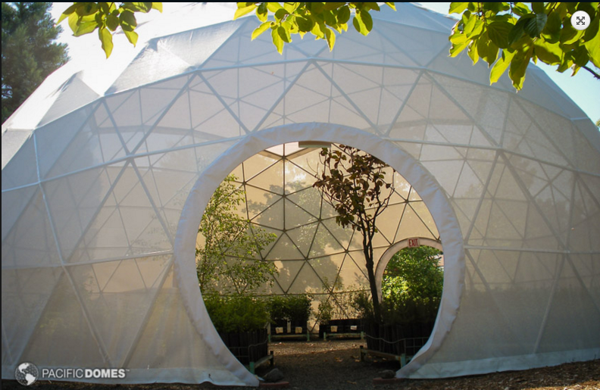
Figure 1: Green house of the company 'pacific domes'[8]
There is also a system for the ventilation implemented in this dome. A piece of the fabric on the base of the dome can be rolled up if necessary. This allows that a great air flow can be infiltrated into this dome. In addition, the roof can be opened, resulting in a chimney effect and in an even better air flow. Another interesting element of the ventilation system is the solar air vent. This is a fan powered by solar energy which can be utilized in a fabric dome. Since it uses solar energy, it can be considered as more or less environmental friendly. A disadvantage of this system is that, without any battery, the vent will only work when there is a sufficient amount of sunlight.

Example 2: Garden Igloo 360 [9]
Another example of a geodesic dome is the “Garden Igloo 360” from the company Garden Igloo. This is a low-cost geodesic dome with a diameter of 3,6 meters. It is obvious that this company has designed this dome, so it would result in a lot of advantages regarding the cost price, fast assemblage and sustainability.
This dome uses PVC as material for the struts. According to Garden Igloo itself, the time to assemble the dome only takes two hours if it is executed by two persons. Also, this dome uses connectors without screws. This also means that this dome can be built without needing any tools. This dome uses 100% recyclable materials. Except for the screws, everything in this dome is made out of PVC. This includes also the cover of the dome.
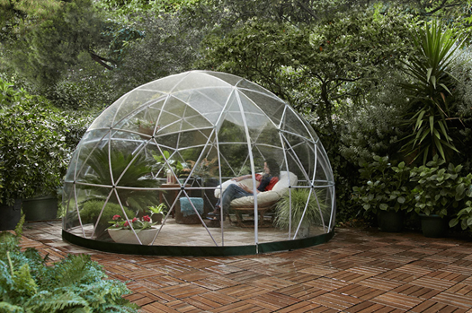
Figure 2: Garden Igloo 360 dome [9]
This dome uses nine different struts and there are also six different connectors. Knowing that you can build a geodesic dome which has almost the same structure as this product with only 3 different pieces, we can conclude that there are too much different struts and connections in this design. The dome can also be transformed to a ‘summer canopy’. There will be even three extra different connections needed. There are two air vents implemented in the cover of the dome. They can be easily opened by using a zipper. Opening the air vents will provide ventilation for the whole space.

General findings of other examples

Besides the two examples that are described more elaborately, there are different other examples available. In general, there are some conclusions that can be drawn from our findings. First of all, the most common technique to connect the struts that is used for domes with a comparable diameter as our dome, is to use only one bolt that connects all the different struts on one node. Second of all, the most common used material for the struts is aluminum. This material has a low-weight and has a good resistance against corrosion, which makes it an ideal material that can be used in outside areas. At last, almost every structure of a spherical dome that has come across during this research is derived from the structure of an icosahedron.

Conclusion State Of The Art
A dome is a very interesting structure due to the many advantages that it has regarding the strength, the usage of materials, the low weight and the fast assemblage. Nevertheless, there are still some problems where a good solution still has not been found.
Nowadays, there are different techniques available on the market for each component of a dome. Nevertheless, most of the domes that are already design and constructed, use almost the same techniques. This phenomenon can have two explanations. First off all, the techniques that are used most of the times are the most available and easiest technique in the market. Another explanation can be that this technique is just the best technique that can be used for this application.

Project development

Introduction
In this chapter, the process of developing this product is discussed. In general, the aim for this product is to have a geodesic dome which can be easily assembled. Additionally, the benefit cost ratio must be as high possible. This means that the development will aim for a product with a lot of benefits for a reasonable price.

V3 or V4 geodesic dome

One task of this project is to choose between a dome with a frequency of three or a dome with a frequency of four. The frequency of a dome is derived from the quantity of subdivisions that are made on each edge of the icosahedron. If a dome has a frequency of V4, it means that all the edges of the dome will be divided in 4 pieces. [10] The new nodes that are made while subdividing the edges, are projected on a sphere, where the center of the icosahedron is the center of the sphere and the radius is the distance between the center of the icosahedron and the vertices.
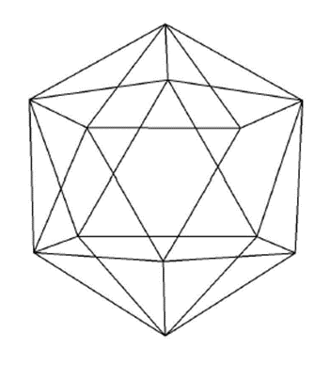
Figure 3: Icosahedron
The higher the frequency is of a dome, the better the spherical structure will be. This is an important aspect which will lead to different advantages and disadvantages for a V3 dome or a V4 dome. First of all, a V3 dome with a flat base can be constructed by only four different faces. Five different faces are needed to construct a V4 dome. There are also less pieces needed in order to construct a V3 dome, being 165 struts and 61 nodes. A V4 dome will need 250 struts and 91 nodes. The struts of a V3 dome will also need less accuracy. These three advantages are all related to the assemblage of a dome. Since this project presents the design of a dome that should be easily assembled, choosing a V3 would be a good fit.
Nevertheless, constructing a V4 geodesic dome comes with plenty of other advantages. A lot of advantages exists because of the smaller struts on the V4 dome. Due to the smaller struts, the constructing will have a better resistance against buckling and bending. This also means that the diameter of the struts can be reduced. A V4 geodesic will be able to distributes loads more evenly over the structure. Furthermore, a V4 dome is also pure esthetically a better look due to the more spherical structure that will be obtained and has a higher design freedom. Thus, there can be concluded that for this project a V4 design would be a better fit.

Structure

The structure is drawn by using AutoCAD 2016. After the drawing is finish, a design as shown as in figure 4 was obtained.
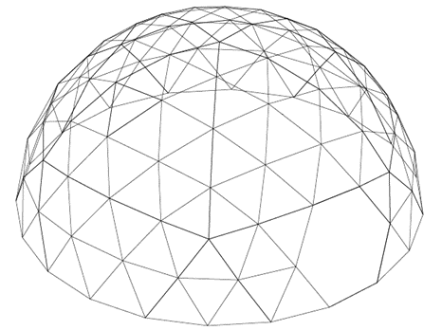
Figure 4: Design 4V dome in AutoCAD
After the design, the length of the different struts can be calculated by using the command ‘distance’ in AutoCAD 2016. Each strut should also have an exact angle to make the connection between the struts possible. The angle is also calculated in AutoCAD by using the command ‘dimang’. In table 1 You can find the different struts of the dome and their length and angle.
Table 1:Different struts and their properties
Strut nr | Length(mm) | Angle (°) | Quantity
1 | 861 | 7,27 | 30
2 | 1001 | 8,47 | 58
3 | 1004 | 8,49 | 30
4 | 1015 | 8,59 | 30
5 | 1064 | 9,00 | 68
6 | 1105 | 9,35 | 28
TOTAL: |  |  | 244

Aluminium is used as a material for the struts. The density of aluminium of 2700 kg/m³ is much lower in comparison with the density of steel, being 7850 kg/m³. [11] [12]Also, aluminium has a good resistance against corrosion. These two main advantages cause that aluminium is the ideal material for the struts of this dome.

Nodes
As mentioned in the state of the art, there are different possibilities available to design a node. The most common technique is a node with only one bolt, which instantly connects all the struts of the node. They have a lot of advantages regarding the time to assemble and the cost price of the materials. It is also easier to find providers for this system. A disadvantage of this system is that the struts will need to be deformed on the sides of the struts, resulting in a lower durability. More innovative techniques are also available. In contrast with the system with only one bolt, no deformation of the struts will be needed. This will result in a better durability. Nevertheless, the innovative systems in general aren’t mostly better regarding the time to assemblage the system. More material and material with a higher grade of complexity is used, which results in a higher cost price for the innovative systems. Since the goal for this research is to obtain a product which can be easy assembled and has a lot of benefits for a low cost, the best node for this application is just one bolt per node which connects all the struts on the node. Figure 5 Shows you an example of the node, which was made as a prototype during this research.
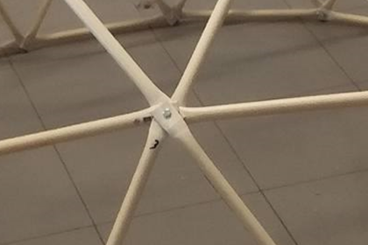
Figure 5: Connection with only one bolt

The door mechanism

Figure 6 shows you the design that is made for the window. The structure consists of 2 main pieces. First of all, we have the not-moveable struts that is a part of the structure of the dome. Second of all, we have the moveable structure of the window.
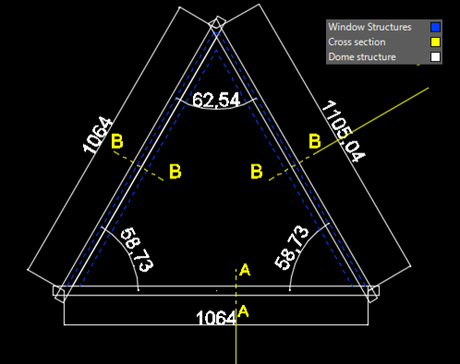
Figure 6: Top view of the door
A big problem for the window is the water infiltration. On Figure 7 you can see the solution for this problem. For the structure of the windows rectangular struts will be used. because it is easier to find a provider who can develop rectangular struts in this form in comparison with circular struts. a good resistance against water infiltration is ensured, by using two water infiltration strips, which are placed on the side and on the top of the window. The fabric will be cut on the two sides of the structure of the window and it will be glued against the bottom of the structure of the window. Extra fabric need to be provided at the place where the fabric was cut.
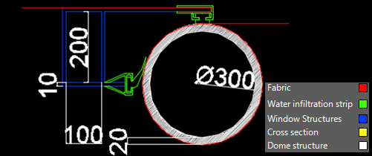
Figure 7: Section B-B
Figure 8 shows you the section A-A of the window. The strut will act as a hinge for the window structure. Another strut with an inner radius of 17 centimeters will be placed over the strut of the dome. This will ensure that the window structure will be able to rotate. On this side of the window, it isn't necessary to cut the fabric. Thus, there won’t be problems with the water infiltration on this side of the window structure.
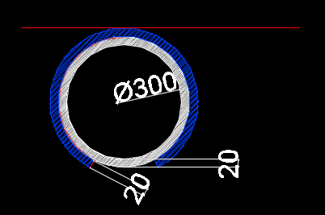
Figure 8: Section A-A

The door mechanism
The aim while designing the door mechanism was to find an easy mechanism that occupies a whole hexagon of the dome, has a good durability and doesn’t need a lot of power. The final design is based on the way blinds for windows work. By pulling a cord, a blind can be opened. Nowadays, there are also motorized blinds available on the market. [13] This design will also use a motor similar to the motors that are used for motorized blinds. The material of the door will contain the same fabric that is used as the cover for the dome. Two aluminium struts will be connected with the fabric, where one will be placed in the middle- and one on the bottom of the door. The aluminium struts will give the system a higher weight, which is needed in order for the door to go down properly without having to use any force. The struts have also another function. The door is placed parallel with the structure of the dome. Figure 9 shows you the system of the door.
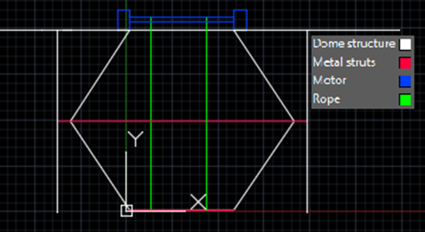
Figure 9: Door mechanism

Assemblage
One main goal of this project is to make the assemblage as easy as possible. This can be executed by choosing a node that can be easily assembled and use as less different pieces as possible. Additionally, every person should be able to make the structure.
For this reason, a clear manual is made in order to help the client during the assemblage, where every step that has to be done is described elaborately. Each different strut is identified with a specific color. Consequently, every strut has a specific color code which is applied on the strut itself. About 10% of males of the total population in the world are color blind or have some form of color blindness. In order to involve these people, color symbols are applied on the strut. This should make a person who has color blindness be able to assemble this dome. The symbols of the color codes are the symbols of the ColorADD project. This is a project to help color blind persons in their daily live. The project has already been presented in different nations.
In table 2 You can find the color and the responding color symbol for each strut of the dome.
Table 2: Color codes of the struts
Strut nr | Color | Color code
1 | Blue | 
2 | Yellow | 
3 | Red | 
4 | White | 
5 | Black | 
6 | Green | 

Testing

Prototype

During this research, a prototype was made in order to test the different components of the dome. This prototype has a scale of 1:3,4. The real model has a diameter of 6,8 meters. Keeping in mind the scale of 1:3,4 the scale prototype has a diameter of 2 meters. Figure 10 presents the prototype after the structure was assembled. Afterwards, the fabric was implemented, as well as the door and the window.
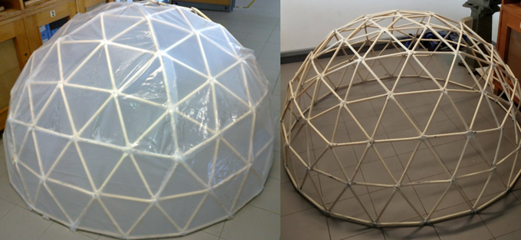
figure 10: (1)Prototype before implementation fabric (2) Prototype after implementation fabric

The structure of the prototype is made from materials that can be found in every work store. For the structure of the dome, 28 plastic tubes with a diameter of 16 millimeters and with a length of 3 meters were used. For the nodes of the base, M6 bolts with a length of 20 millimeters are used. For the other nodes M5 bolts with a length of 30 millimeters are used. For the base of the dome it was possible to use smaller bolts, because there were only 4 struts that need to be connected on each node. The other nodes connect 5 or 6 struts with each other, which makes it difficult to assemble the node with bolts with a length of 20 millimeters.
The fabric that is used for making the cover is originally fabric that is used from a greenhouse. This fabric is transparent and has a sufficient thickness to make it strong enough to use it for the cover of our dome.
The structure of the window itself is made from rigid polyvinyl chloride with a thickness of 3 millimeters.

Tests

In order to evaluate our system, there are different tests that need to be carried out. The tests that were executed are essential to confirm that the scale prototype is functional. If the scale prototype passes the tests that were executed, it will be very likely that the full scale model will also be functional and will have the properties that we promised to our clients. Most of the tests can be executed in an easy way.
In general, we can distinguish three different types of tests that are executed: tests for the electrical components, Tests concerning the structure and the tests concerning the functioning of the automatic window and door.
The tests concerning the electrical components are executed in order to check if every single component is working and if each component is compatible to work in the system. Every electrical component has a specific function. If one component isn’t working properly, the system will possibly not work. Thereby it is essential to test the electrical components. Also the functioning of the total electrical system is checked.
The structural tests are executed to examine the strength and the durability of the scale model. All of the struts should be connected properly. There shouldn’t be any deformations that could lead to instability of the structure. These tests can be executed visible. For this test, a load of … is applied on a node of the dome. While the load applied, a visible checkup is done for each node and strut. Another matter that we need to test is the resistance of the fabric for water infiltration.
The window and the door should be tested if they function properly. The door and the window should open easily and should be durable enough to keep on working after a large amount of openings and closes. In order to test this the window and door can be opened for a large amount of times and see if the system still operates on the same way as before.

Results
The system is developed to be assembled as easy as possible. The node that was chosen is very easy to assemble. The use of color codes is also a good way to simplify the assemblage process and to include people who suffer from color blindness.
Concerning the structure of the dome, A V4 geodesic dome is chosen because of the advantages regarding the smaller lengths and diameter of the struts. Nevertheless, a V3 dome has better properties concerning the easiness to assemble.
The use of aluminium as material for the struts is a sustainable decision. Due to the low density of aluminium, the dome will be easy to move. In total, the dome will have a weight of more or less 150 kilograms. This makes it able to move the dome with only a few people.
The solution of the door and window is functioning. although, the durability in time has not been proven yet.
The tests that were executed on the scale prototype of the dome have all been passed. The sensors are responding to changes in temperature and humidity. This gives more certainty that the full scale model of this product will also be able function properly.

Discussion
The outcome of this project is a product that can be assembled easily. It is designed in a way that the client will have a lot of benefits for a reasonable price. Nonetheless, there are some aspects of this design that need to be discussed.
First of all, a main goal for this project was to find an easy and innovative system to connect the struts. The node that is chosen is not innovative, but it is the easiest and most common node that is used nowadays. You can say that there is no need for an innovative system if the properties of the nodes aren’t good enough.
An intentional choice for constructing a V4 dome has been made, which leads to less advantages regarding assembling the dome. If the necessity is that big to have a dome where the assembling time is optimized as best as possible, a V3 would be better. Since the assemblage isn’t the only factor that needs to be taken into account while designing a dome, it is better to have V4 structure.
The designs of the window and the door are easy systems. Yet, the easiness of the design shouldn’t evolve into an unsustainable system after perennial usage.
Tests are executed on a scale model. A real scale model should be built in order to certain that this system is working.

Additional research

Introduction
As said in the introduction, this paper presents the findings of an EPS project. This project is multidisciplinary, which means that research has been done concerning the different disciplines in designing a product. In this chapter, a summary of the findings of additional researches are presented.

Eco-Eficiency Measures for Sustainability

With global warming influencing, consumer-purchasing habits and renewable energy are becoming more accessible. People are seeking ways on how to be eco-friendly. The dome fits to these concepts, we aspire to build an environmentally friendly green house.
Using the same amount of material, The round shape of the dome can encompass more space than traditional structures. Compared with a similar sized rectangularly-shaped building, the dome has 30 % less surface area. [2] This leads to spare huge amount of material and of course leads to a savings of natural resources, energy, and labour.
With the simple addition of a low voltage wiring system, electricity is supplied with solar energy. The mobility of the dome is really important; people can change the place of it easily whenever they want. In that case solar energy source seems the best solution, furthermore this is a clean and renewable energy source. Once a solar panel is installed, solar energy can be produced free of charge and this kind of energy causes no pollution. Solar cells make absolutely no noise at all. Solar power is used to charge a battery, so the solar powered devices can be used at night. Unfortunately in some years the battery has to be replaced which is a kind of a pollution.
A very sustainable materials are used, being aluminium. Aluminium requires little energy to be remelted. According to the International Aluminium Institute over 90 million tonnes of CO2 and over 100,000 GWh of electrical energy is saved by recycling aluminium. It also needs 95 per cent less energy to recycle than to produce primary metal [14]
The manufacturing is outside and during the day, it doesn’t need any lighting. Some tools as drills, press and saws are needed to cut and shape each one of the aluminium beams. If the beams are well prepared, the next step is to connect them to each other and it’s possible, so also recommended to do this without using any electricity.
All in all, this movable geodesic dome is in harmony with the nature. The greenhouse contains the minimum amount of material and it also use a minimal amount of electricity which is also an eco-friendly renewable solar energy.

Ethical and deontological concerns
In an era in which capitalism is maybe living its last period in this form, when consumerism is promoted by all means, the company believes that, ethical concepts are vital. When talking about consumerism, the purpose is to point out that the aforementioned represents the ideology according to which the population must buy a lot of stuff based on artificially stimulated desires, not needs.
To encourage consumerism and the present type of capitalism, products are developed with a reduced life cycle because the buyer will be obliged to buy after a while same type of product but with afferent updates, affecting the user and the environment as well. The company doesn't support anti-consumerism, but in terms of the project, the environment and the consumers interests can't be affected in any way.
To counter these trends the company has decided to implement these solutions for product:
The potential consumers will have real advertising that has all the technical and non-technical details. The advertisement won't consist of exaggerations and no information will be hidden for the customers. The costumer will obtain a true image of the product.
In the environmental sense will be used only materials that can be recycled easily and with a good life cycle. Once it's implemented this will result in a product that would have two big advantages, will be with the minimal influence for the nature and sustainability.
The metallic structure of the dome will be built with components of aluminium, that is 100 per cent recyclable without damaging to material quality, statistics say that over 75 per cent of the aluminium produced since its discovery is still in use. As well the fabric cover is a recyclable plastic material. [15].
In order to strengthen the above, it’s worth highlighting that the automatic door and window of the fabric and metallic dome have the quality of being easy to assemble and disassemble. It means that the dome can be mounted to a specific location, and when the consumer needs it in another location it can be disassembled, easily transported and installed in the new location.

Marketing
By Analyzing the market and factors that have influence on the market itself the team is able to direct actions and plans regarding product development. Nowadays the society is starting to be eco-oriented, also trends in spending time, eating habits are changing. [16]
The dome can face new needs of customers, as it can offer a place for people who are leading a slow life lifestyle, who want to grow their own bio-food but also can create a space for people who just need a temporary place to relax. Creating or finding a potential market for the dome means also finding the ability of distinction between the product from others-similar available for the customer. Looking through competitors it is easy to assume that there is no exactly the same product. What makes the dome different is its size-it is big when it comes to domes that are offered by competitors for personal use and also smaller from other competitors who are creating domes for larger amount of people, but also the price which is supposed to be very attractive taking into consideration all of the features: size, automatic door, windows and sensors monitoring temperature and humidity inside the dome.
The other positive aspects of the dome are using the concept of do it yourself -it encourages people to buy it just to have a satisfaction from building something with own hands and it being portable, with the weight of structure approximately 150 kg it can be easily transported by for instance a truck or with some people. It also needs to be considered how to get to the client, both when it comes to information and the product itself.
The best approach in promotion is putting modern advertisement, like online, trade shows, public relation first as target group is mainly using devices which have connection to the Internet. But the traditional way of advertisement, like leaflets, posters, television cannot be omitted. When it comes to distribution this kind of new company/product can have different methods, it this case the team is mostly interested in direct selling to the client to create a brand and long term relationships with customers.

Conclusion

This paper contains every part of the research that has been executed in a multidisciplinary a multicultural team. Apart from the technical knowledge, there is also an even more important knowledge that is obtained for each member of the group during this program, which is the knowledge to collaborate with people with a different cultural and scientific background. This knowledge would come in handy for the future career for every team member.
Regarding the project, an easy solution has been found for every main goal of the project. Thus, the design should be able to be build and should function as projected in this paper.
The next after this research can be to build a real scale, which can be tested elaborately. Then afterwards, the benefits of this can be possibly be expanded, by implementing extra sensors and features.

Acknowledgements
All the team members would like to express their gratitude to some persons and organizations who aided in this research
First of all, we would like to thank the panel of supervisors of this project for giving us advice and helping us to find a solution for the problems that need to be solved. We want to thank Benedita Malheiro in particularly, as well as Abel Duarte and Fernando Ferreira, who acted like the head supervisors for this project.
We also want to thank ISEP and the home universities of each team member for giving the opportunity to do an EPS program and for providing a place where this project could be executed.
The team members also want to express their gratitude to the teachers of ISEP that gave us interesting lectures during the semester.

BIBLIOGRAPHY

[1] Mysid and Propuff, “Three golden rectangles in a icosahedron,” wikipedia, 2006. [Online]. Available: https://en.wikipedia.org/wiki/Golden_rectangle#/media/File:Icosahedron-golden-rectangles.svg.
[2] D. Spaces, “Different Spaces,” 2013. [Online]. Available:https://sites.google.com/site/dsdomes/conceptos. [Accessed: 04-Mar-2016].
[3] R. Schackelford and M. Fitgerald, “Dome Sweet Dome,” 2007. .
[4] R. Guy, “What are the pros and cons of building and living in a geodesic dome house?,” 2012. [Online]. Available: https://www.quora.com/What-are-the-pros-and-cons-of-building-and-living-in-a-geodesic-dome-house/answer/Richard-Guy-1. [Accessed: 02-Mar-2016].
[5] “Refried domes,” Shelter publications. [Online]. Available:http://www.shelterpub.com/domes/#refried-domes. [Accessed: 02-Jun-2016].
[6] Swanzart, “Wellness dome.” [Online]. Available: http://www.swanzart.com/wellness_dome.php. [Accessed: 15-Mar-2016].
[7] Investopedia, “Benefit Cost Ratio,” 2016. [Online]. Available:http://www.investopedia.com/terms/b/bcr.asp. [Accessed: 02-Jun-2016].
[8] PacificDomes, “Greenhouse domes,” 2016. [Online]. Available: http://pacificdomes.com/greenhouse-domes/. [Accessed: 12-Mar-2016].
[9] G. Igloo, “GardenIgloo,” Inhabitat LLC, 2016. [Online]. Available: http://gardenigloo.com/.
[10] Geo-Dome, “Geodesic dome frequency explained.” [Online]. Available: http://geo-dome.co.uk/article.asp?uname=domefreq. [Accessed: 29-Feb-2016].
[11] Azom, “Aluminium Alloy 6061 - Composition, Properties, Temper and Applications of 6061 Aluminium,” 2013. [Online]. Available: http://www.azom.com/article.aspx?ArticleID=3328#_Typical_Heat_Treatment/Temper_State. [Accessed: 20-May-2016].
[12] Tosec, “Staal: S235, S275, S355 – Toepassing en eigenschappen van staal,” 2016. [Online]. Available: http://www.tosec.nl/wiki/staal/. [Accessed: 20-May-2016].
[13] Somfy, “how much do motorized shades cost,” 2016. [Online].Available:https://www.somfysystems.com/ideas-insights/considering-motorization/how-much-do-motorized-blinds-cost. [Accessed: 04-Jun-2016].
[14] I. A. Institute, “Sustainability,” 2016. [Online]. Available: http://recycling.world-aluminium.org/review/sustainability.html. [Accessed: 04-Jun-2016].
[15] Constellium, “About aluminium,” 2016. [Online]. Available: http://www.constellium.com/aluminium-company/aluminium-properties-and-uses#top. [Accessed: 04-Jun-2016].
[16] Wbcsd, “Sustainable Consumption Facts and Trends, From a business perspective - The Business Role Focus Area,” World Bus. Counc. Sustain. Dev., p. 40, 2008.

